RAJIV GANDHI CLLEGE OF ENGINEERING AND TECHNOLOGY DEPARTMENT OF MECHANICAL ENGINEERING
T105 - ENGINEERING THERMODYNAMICS
UNIT III – SECOND LAW OF THERMODYNAMICS

UNIT III – Equilibrium and the second law – Heat engines – Kelvin-Plank statement of second law of thermodynamics – Reversible and irreversible processes – Carnot principle – Clausius inequality – Entropy

Part - A QUESTION

- Define a heat engine.
A heat engine is a device which extracts heat from a hot reservoir (source), converts it into useful work and a part of heat energy is rejected to a cold reservoir (sink).
- Define the terms heat source and heat sink.
  - Heat source: It is a thermal energy reservoir (TER_{H}) which supplies heat continuously to the system operating in a cyclic process.
  - Heat sink: It is a thermal energy reservoir (TER_{S}) which absorbs heat continuously from the system operating in a cyclic process.
- Define refrigerator.
Refrigerator is a device which extracts heat from a system to maintain its temperature lower than the surrounding.
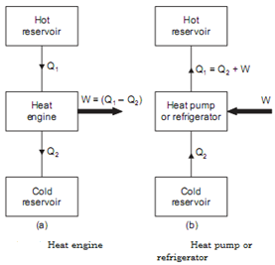
- Define heat pump. (May 2012)
Heat pump is a device which supplies heat to a system to maintain its temperature higher than the surrounding.
- Define thermal efficiency.
Thermal efficiency is defined as the ratio of net work transfer from the engine (W) to the net heat transfer from the engine (Q).

- Define COP of a refrigerator.
Coefficient of performance (COP) of a refrigerator is defined as the ratio of heat extracted from the system (Q) to the work input to the refrigerator (W).
- Define COP of a heat pump.
COP of a heat pump is defined as the ratio of heat rejected to the system (Q) to the work input to the heat pump (W).
- Write Kelvin-Planck statement for second law of thermodynamics. (May 2015, May 2016)
“It is impossible to construct an engine, working on a cyclic process which converts all the heat energy supplied to it into equivalent amount of useful work”.
Simply we can say that “all the heat energy given to an engine cannot be converted in to useful work and some amount of heat energy will be rejected”.
- State Clausius statement. (May 2014)
“It is impossible for a self acting machine working in a cyclic process to transfer heat from a body at a lower temperature to a body at a higher temperature”, without any external aid. But can ‘transfer from higher temperature to lower temperature’ without any external aid.
- What do you mean by perpetual motion machine of second kind (PMM- II)? (Jan 2014)
- A PMM – II is the machine which receives heat energy from hot reservoir and converts it into equivalent amount of work. i.e. PMM-II gives 100% efficiency.
- This is violates the second law of thermodynamics.
- Therefore it is impossible to construct.
- What is a heat engine cycle?
A heat engine cycle is a thermodynamic cycle in which there is a net heat transfer to the system and a net work transfer from the system.
- State Carnot theorem.(May 2012)
It states that “No heat engine operating in a cyclic process between two fixed temperatures can be more efficient than a reversible engine while operating between the same temperature limit”.

- State Corollaries of Carnot theorem. (Jan 2013)
Corollary I:
All reversible engines operating between the two given temperature limits have the same efficiency.
Corollary II:
Efficiency of the entire reversible engine depends only on the temperature limit of the reservoirs and is independent of the nature of working fluid.
- Sketch the p-V and T-S diagram for Carnot cycle.
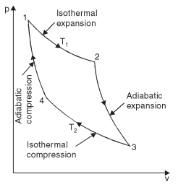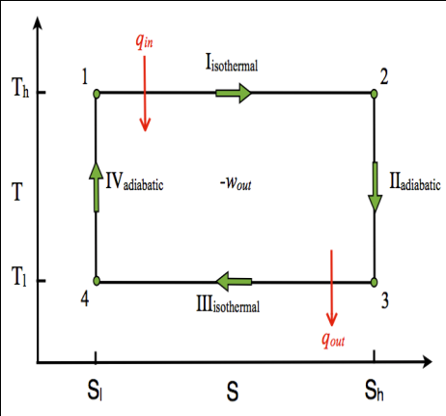
P-V and T-S diagram of Carnot cycle
- Write the Clausius inequality.
The Clausius inequality may be expressed as follows: “When a system performs a reversible cycle, then

But when the cycle is irreversible


- What is the difference between a heat pump and a refrigerator?
- Heat pump is a device which operating in cyclic process, maintains the temperature of a
hot body at a temperature higher than the temperature of surroundings.
- A refrigerator is a device which operating in a cyclic process, maintains the temperature
of a cold body at a temperature lower than the temperature of the surroundings.

- What are the assumptions made on heat engine?
  - The source and sink are maintained at constant temperature.
  - The source and sink has infinite heat capacity.
- Why Carnot cycle cannot be realized in practical?
  - In a Carnot cycle all the four processes are reversible but in actual practice there is no
process is reversible.
  - There are two processes to be carried out during compression and expansion. For
isothermal process the piston moves very slowly and for adiabatic process the piston moves
as fast as possible. This speed variation during the same stroke of the piston is not possible.
  - It is not possible to avoid friction moving parts completely.
- Name two alternative methods by which the efficiency of a Carnot cycle can be increased.
  - Efficiency can be increased as the higher temperature T₂ increases.
  - Efficiency can be increased as the lower temperature T₁ decreases.
- Why a heat engine cannot have 100% efficiency?
For all the heat engines there will be a heat loss between system and surroundings.
Therefore we can’t convert all the heat input into useful work.
- What are the processes involved in Carnot cycle.
Carnot cycle consist of
  - Reversible isothermal compression
  - Isentropic compression
  - Reversible isothermal expansion
  - Isentropic expansion
- What are the limitations of Carnot cycle?
  - No friction is considered for moving parts of the engine.
  - There should not be any heat loss.
- What is meant by reversible process? (May 2016)
A system pass through an infinite number of continuous equilibrium state and it traces the same path when the process is reversed. This process is called as reversible process.
E.g. Constant volume, constant pressure, isothermal, adiabatic process.
- What is meant by irreversible process?
A system passes through an infinite number of non-continuous equilibrium states and does not trace the same path when the process is reversed. This process is called as irreversible process.
E.g. free expansion process, Throttling process, and steady flow process.

- Explain entropy? (May 2015)
It is an important thermodynamic property of the substance. It is the measure of
molecular disorder. It is denoted by S. The measurement of change in entropy for reversible
process is obtained by the quantity of heat received or rejected to absolute temperature.
- Define availability.
The maximum useful work obtained during a process in which the final condition of the
system is the same as that of the surrounding is called availability of the system.
- Define available energy. (Jan 2013)
It is the part of energy, which has been converted in to useful work output in a process and is termed as waste energy. Type: high grade energy, low grade energy.
- Define unavailable energy. (Jan 2014)
It is the part of energy, which cannot be converted in to useful work output in a process and is termed as waste energy.
- What do you understand by the entropy principle?
The entropy of an isolated system can never decrease. It always increases and remains
constant only when the process is reversible. This is known as principle of increase in entropy or
entropy principle.
- What are the important characteristics of entropy? (Jan 2013)
- If the heat is supplied to the system then the entropy will increase.
- If the heat is rejected to the system then the entropy will decrease.
- The entropy is constant for all adiabatic frictionless process.
- The entropy increases if temperature of heat is lowered without work being done as in throttling process.
- If the entropy is maximum, then there is a minimum availability for conversion in to work.
- If the entropy is minimum then there is a maximum availability for conversion into work.

- What is meant by perpetual motion machine-II? (Jan 2010)
- A machine which violates the second law of thermodynamics is called PMM-2.
- It is defined as a machine which converts whole of heat energy into mechanical work.

